**2.3 PROCESS MODEL USED WITH JUSTIFICATION**

**SDLC (Umbrella Model):**

**Umbrella Activity**

**Umbrella Activity**

**Umbrella Activity**

1. Feasibility Study
2. TEAM FORMATION
3. Project Specification PREPARATION

Business Requirement Documentation

ANALYSIS & DESIGN

CODE

UNIT TEST

DOCUMENT CONTROL

ASSESSMENT

TRAINING

INTEGRATION & SYSTEM TESTING

DELIVERY/INSTALLATION

ACCEPTANCE TEST

Requirements Gathering

SDLC is nothing but Software Development Life Cycle. It is a standard which is used by software industry to develop good software.

**Stages in SDLC:**

* Requirement Gathering
* Analysis
* Designing
* Coding
* Testing
* Maintenance

**Requirements Gathering** **stage:**

The requirements gathering process takes as its input the goals identified in the high-level requirements section of the project plan. Each goal will be refined into a set of one or more requirements. These requirements define the major functions of the intended application, define

operational data areas and reference data areas, and define the initial data entities. Major functions include critical processes to be managed, as well as mission critical inputs, outputs and reports. A user class hierarchy is developed and associated with these major functions, data areas, and data entities. Each of these definitions is termed a Requirement. Requirements are identified by unique requirement identifiers and, at minimum, contain a requirement title and

textual description.

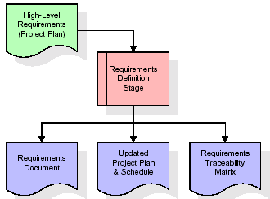

These requirements are fully described in the primary deliverables for this stage: the Requirements Document and the Requirements Traceability Matrix (RTM). The requirements document contains complete descriptions of each requirement, including diagrams and references to external documents as necessary. Note that detailed listings of database tables and fields are *not* included in the requirements document.

The title of each requirement is also placed into the first version of the RTM, along with the title of each goal from the project plan. The purpose of the RTM is to show that the product components developed during each stage of the software development lifecycle are formally connected to the components developed in prior stages.

In the requirements stage, the RTM consists of a list of high-level requirements, or goals, by title, with a listing of associated requirements for each goal, listed by requirement title. In this hierarchical listing, the RTM shows that each requirement developed during this stage is formally linked to a specific product goal. In this format, each requirement can be traced to a specific product goal, hence the term *requirements traceability*.

The outputs of the requirements definition stage include the requirements document, the RTM, and an updated project plan.

* Feasibility study is all about identification of problems in a project.
* No. of staff required to handle a project is represented as Team Formation, in this case only modules are individual tasks will be assigned to employees who are working for that project.
* Project Specifications are all about representing of various possible inputs submitting to the server and corresponding outputs along with reports maintained by administrator

**Analysis Stage:**

The planning stage establishes a bird's eye view of the intended software product, and uses this to establish the basic project structure, evaluate feasibility and risks associated with the project, and describe appropriate management and technical approaches.

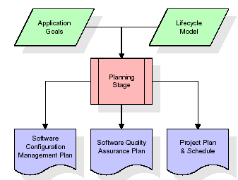

The most critical section of the project plan is a listing of high-level product requirements, also referred to as goals. All of the software product requirements to be developed during the requirements definition stage flow from one or more of these goals. The minimum information for each goal consists of a title and textual description, although additional information and references to external documents may be included. The outputs of the project planning stage are the configuration management plan, the quality assurance plan, and the project plan and schedule, with a detailed listing of scheduled activities for the upcoming Requirements stage, and high level estimates of effort for the out stages.

**Designing Stage:**

The design stage takes as its initial input the requirements identified in the approved requirements document. For each requirement, a set of one or more design elements will be produced as a result of interviews, workshops, and/or prototype efforts. Design elements describe the desired software features in detail, and generally include functional hierarchy diagrams, screen layout diagrams, tables of business rules, business process diagrams, pseudo code, and a complete entity-relationship diagram with a full data dictionary. These design elements are intended to describe the software in sufficient detail that skilled programmers may develop the software with minimal additional input.

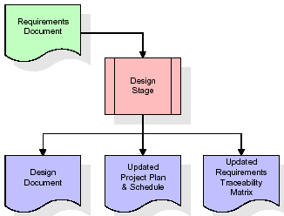

When the design document is finalized and accepted, the RTM is updated to show that each design element is formally associated with a specific requirement. The outputs of the design stage are the design document, an updated RTM, and an updated project plan.

**Development (Coding) Stage:**

The development stage takes as its primary input the design elements described in the approved design document. For each design element, a set of one or more software artifacts will be produced. Software artifacts include but are not limited to menus, dialogs, data management forms, data reporting formats, and specialized procedures and functions. Appropriate test cases will be developed for each set of functionally related software artifacts, and an online help system will be developed to guide users in their interactions with the software.

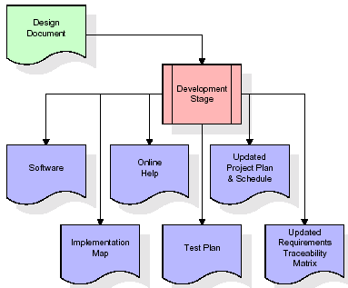

The RTM will be updated to show that each developed artifact is linked to a specific design element, and that each developed artifact has one or more corresponding test case items. At this point, the RTM is in its final configuration. The outputs of the development stage include a fully functional set of software that satisfies the requirements and design elements previously documented, an online help system that describes the operation of the software, an implementation map that identifies the primary code entry points for all major system functions, a test plan that describes the test cases to be used to validate the correctness and completeness of the software, an updated RTM, and an updated project plan.

**Integration & Test Stage:**

During the integration and test stage, the software artifacts, online help, and test data are migrated from the development environment to a separate test environment. At this point, all test cases are run to verify the correctness and completeness of the software. Successful execution of the test suite confirms a robust and complete migration capability. During this stage, reference data is finalized for production use and production users are identified and linked to their appropriate roles. The final reference data (or links to reference data source files) and production user list are compiled into the Production Initiation Plan.

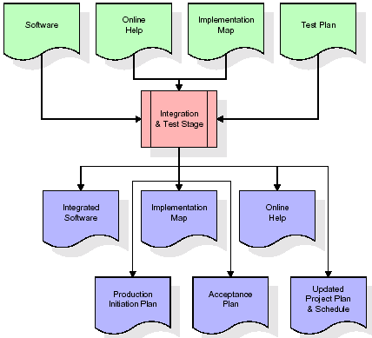

The outputs of the integration and test stage include an integrated set of software, an online help system, an implementation map, a production initiation plan that describes reference data and production users, an acceptance plan which contains the final suite of test cases, and an updated project plan.

* **Installation & Acceptance Test:**

During the installation and acceptance stage, the software artifacts, online help, and initial production data are loaded onto the production server. At this point, all test cases are run to verify the correctness and completeness of the software. Successful execution of the test suite is a prerequisite to acceptance of the software by the customer.

After customer personnel have verified that the initial production data load is correct and the test suite has been executed with satisfactory results, the customer formally accepts the delivery of the software.

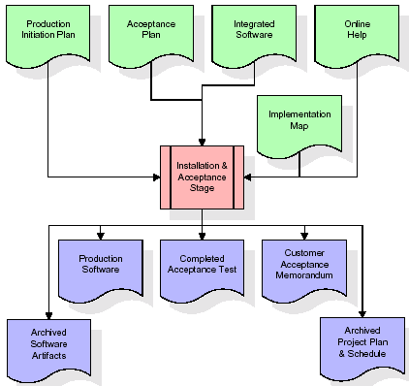

The primary outputs of the installation and acceptance stage include a production application, a completed acceptance test suite, and a memorandum of customer acceptance of the software. Finally, the PDR enters the last of the actual labor data into the project schedule and locks the project as a permanent project record. At this point the PDR "locks" the project by archiving all software items, the implementation map, the source code, and the documentation for future reference.

**Maintenance:**

Outer rectangle represents maintenance of a project, Maintenance team will start with requirement study, understanding of documentation later employees will be assigned work and they will under go training on that particular assigned category.

For this life cycle there is no end, it will be continued so on like an umbrella (no ending point to umbrella sticks).

**2.4 SYSTEM ARCHITECTURE**

**Architecture flow:**

Below architecture diagram represents mainly flow of requests from users to database through servers. In this scenario overall system is designed in three tires separately using three layers called presentation layer, business logic layer and data link layer. This project was developed using 3-tire architecture.

**SERVER**

**User**

**Data Base**

**Request**

**Response**

**URL Pattern:**

**Presentation Layer**

**SERVLETS AT THE SERVER SIDE**

**URL Request sent through the browser**

**Response sent from the servlet**

**DATABASE**

**Verifying or updating the database** **through a statement**

**Reply from the database according to the statement**

URL pattern represents how the requests are flowing through one layer to another layer and how the responses are getting by other layers to presentation layer through server in architecture diagram.